Introduction To JAVA Technology

Gurpreet Kaur
Asstt. Prof.IT,Ghaziabad

What is JAVA?
- Java is a high-level, robust, secure, and object-oriented programming language developed by Sun Microsystems (now part of Oracle Corporation) and officially released in 1995.
- Java is platform-independent, meaning Java programs can run on any operating system with any processor type, as long as the Java Virtual Machine (JVM) is installed.
- The core principle of Java is WORA (Write Once, Run Anywhere)—Java code compiled on one platform can run on any other without recompilation.
- It is widely used in web development, mobile apps (especially Android), enterprise software, cloud computing, and IoT.

History of JAVA

• The Java project was started in June 1991 by James Gosling, Mike Sheridan, and Patrick Naughton, as part of a team called the Green Team at Sun Microsystems.
• Originally designed for embedded systems in appliances like televisions and set-top boxes.

• Initially named "Greentalk", with files using the .gt extension.
• Later renamed to "Oak", inspired by an oak tree outside James Gosling’s office.
• In 1995, Oak was renamed to "Java", because “Oak” was already trademarked.
• The name “Java” was chosen from a list of suggestions because of its connection to coffee (Java coffee) and simplicity.


🔷 Java Version Release History (Updated till 2025)

Java Version | Release Date | Notable Features
JDK 1.0 | January 1996 | Initial version – basic classes, AWT, applet support
JDK 1.1 | February 1997 | Inner classes, JDBC, RMI, reflection
J2SE 1.2 | December 1998 | Collections Framework, Swing, JIT compiler
J2SE 1.3 | May 2000 | HotSpot JVM, RMI over IIOP
J2SE 1.4 | February 2002 | assert keyword, regex, NIO, logging API
J2SE 5.0 | September 2004 | Generics, annotations, autoboxing, enhanced for-loop
Java SE 6 | December 2006 | Scripting API, JAXB, improved Web Services
Java SE 7 | July 2011 | try-with-resources, switch with strings, NIO.2
Java SE 8 | March 2014 | Lambda expressions, Streams API, new Date/Time API
Java SE 9 | September 2017 | JPMS (Module System), JShell
Java SE 10 | March 2018 | Local variable type inference (var)
Java SE 11 | September 2018 | LTS release, HTTP client API, removal of Java EE modules
Java SE 12 | March 2019 | Switch expressions (preview), new GC features
Java SE 13 | September 2019 | Text blocks (preview), dynamic CDS archives
Java SE 14 | March 2020 | Records (preview), instanceof enhancements
Java SE 15 | September 2020 | Sealed classes (preview), hidden classes
Java SE 16 | March 2021 | Records (standard), pattern matching
Java SE 17 | September 2021 | LTS release, sealed classes (standard), new macOS rendering
Java SE 18 | March 2022 | UTF-8 by default, simple web server
Java SE 19 | September 2022 | Virtual threads (preview), structured concurrency
Java SE 20 | March 2023 | Scoped values, pattern matching updates
Java SE 21 | September 2023 | LTS release, virtual threads (standard), string templates
Java SE 22 | March 2024 | Stream gatherers, unnamed variables in patterns
Java SE 23 | September 2024 | (Expected: More pattern matching and value object enhancements)
Java SE 24 | March 2025 (expected) | (Speculative: Refinement of Project Valhalla and Panama features)
LTS (Long Term Support) versions are Java 8, 11, 17, and 21, with Java 25 expected as the next LTS in September 2026.

Full Form and Meaning of Java SE 24

Java SE 24 stands for:
Java Platform, Standard Edition version 24

Breakdown of the Term:

- Java: A high-level, object-oriented programming language and computing platform developed by Sun Microsystems (now Oracle).
- SE: Standard Edition
  - Refers to the standard platform for developing and running Java applications.
  - It includes core libraries, the Java Virtual Machine (JVM), and APIs required for general-purpose application development.
- 24: The version number indicating the 24th major release in the Java SE series.

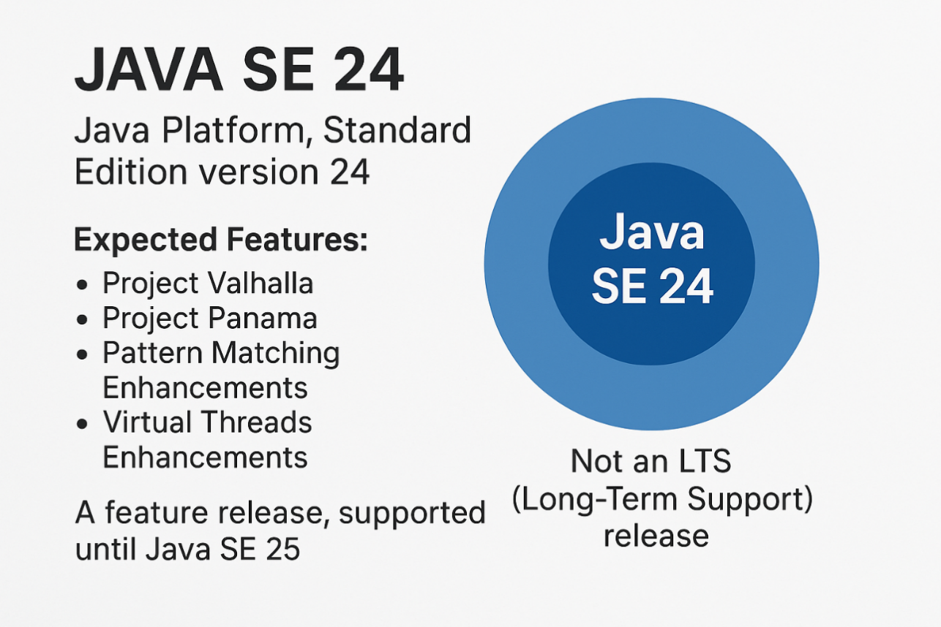

1. Project Valhalla – Value Types for Performance
🧠 What it is:
Project Valhalla introduces value objects—lightweight, immutable objects without identity. Think of them like int or double, but for custom user-defined classes.
🔧 Technical Use:
- Improves performance by avoiding object overhead and heap allocation.
- Uses "inline classes" (preview in recent versions), allowing the JVM to optimize memory layout and access.
✅ Real-life Use Case:
Imagine you’re building a game or financial app that deals with millions of coordinates, Point(x, y):
Without Valhalla:
java
CopyEdit
class Point {
int x, y;
}
Each Point is an object → stored on heap → takes memory + GC overhead.
With Valhalla (inline class):
java
CopyEdit
value class Point {
int x, y;
}
Now it’s treated like a struct in C – faster, less memory, ideal for AI models, game engines, and data science platforms like Apache Arrow.
🔶 2. Project Panama – Better Native Code Interfacing (C/C++)
🧠 What it is:
Panama makes it easier and faster to call native libraries (written in C/C++) from Java, without JNI boilerplate.
🔧 Technical Use:
- Replaces the outdated JNI (Java Native Interface)
- Brings a Foreign Function & Memory API to safely access native memory
- Supports calling C libraries directly

✅ Real-life Use Case:
Suppose you're building a high-performance image processing or machine learning application and want to use a native C++ library like OpenCV:Without Panama:
- You write complex JNI code.
- Hard to debug, verbose.
With Panama:
java
CopyEdit
Linker linker = Linker.nativeLinker();
MethodHandle add = linker.downcallHandle(...);
add.invoke(...);
Used in:
- High-frequency trading platforms
- AI/ML bridges
- Bioinformatics tools
- Java + TensorFlow integration
🔶 3. Pattern Matching Enhancements – Cleaner & Smarter Type Checking
🧠 What it is:
Enhances the instanceof operator and switch to allow pattern-based type extraction and matching, making code shorter and more readable.
🔧 Technical Use:
Old way:
java
CopyEdit
if (obj instanceof String) {
String s = (String) obj;
...
}
New way:
java
CopyEdit
if (obj instanceof String s) {
...
}
Also extended to switch:
java
CopyEdit
switch (obj) {
case String s -> System.out.println(s.length());
case Integer i -> System.out.println(i + 1);
...
}
✅ Real-life Use Case:
Used in:
- Data processing pipelines
- Parsers, compilers
- Any application doing lots of object-type switching like in IDE plugin dev (JetBrains, Eclipse)
Helps reduce boilerplate and bugs in large-scale apps.
🔶 4. Virtual Threads (Project Loom) – Lightweight, Scalable Concurrency
🧠 What it is:
Adds virtual threads—lightweight, managed threads by JVM. You can now create millions of threads without the cost of OS threads.
🔧 Technical Use:
Traditional threading:
java
CopyEdit
new Thread(() -> { ... }).start();
Too many threads = slow + memory-intensive.
Now:
java
CopyEdit
Thread.startVirtualThread(() -> {
// cheap thread
});
Thousands of concurrent tasks → handled efficiently.
✅ Real-life Use Case:
Perfect for:
- Web servers: handling thousands of simultaneous HTTP requests
- Chat applications, API gateways
- Used in: Spring Boot 6 (with virtual thread support), Quarkus, Jetty, Netty
✅ Netflix, Amazon, and enterprise-scale cloud platforms are experimenting or adopting this for high-throughput services.
✅ Summary Table:
Feature | Solves What? | Used In
Project Valhalla | Reduce memory, boost performance | Game engines, data science tools, analytics
Project Panama | Easier C/C++ integration | Image/ML tools, FinTech, scientific computing
Pattern Matching | Cleaner conditional logic | Compilers, IDEs, parsers
Virtual Threads (Loom) | Scalable, concurrent applications | Web servers, chat apps, real-time dashboards
Applications of JAVA

  - Console Applications
  - Windows Applications
  - Web Applications
  - Enterprise Applications (large-scale, multi-tiered, scalable, reliable, and secure network applications)
  - Mobile Applications

JAVA Editions

  - J2SE (Java 2 Standard Edition)

  - J2EE (Java 2 Enterprise Edition)

  - J2ME (Java 2 Micro Edition)

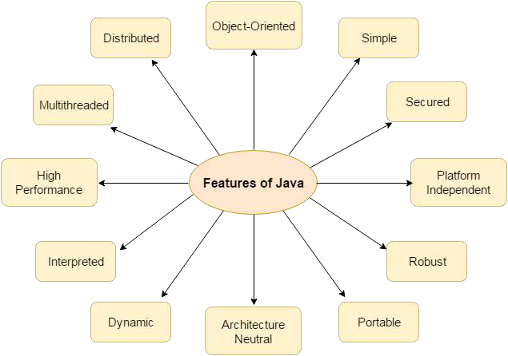
Features of JAVA

Steps for Setting up Java Environment for Windows
- Download Java8 JDK from the following URL :
https://www.oracle.com/technetwork/java/javase/downl oads/jdk8-downloads-2133151.html
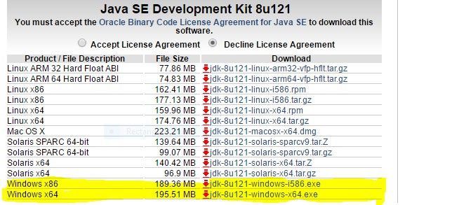
- Click second last link for Windows(32 bit) and last link for Windows(64 bit) as highlighted below.

- After download, run the .exe file and follow the instructions to install Java on your machine. Once you installed Java on your machine, you have to setup environment variable(Path).
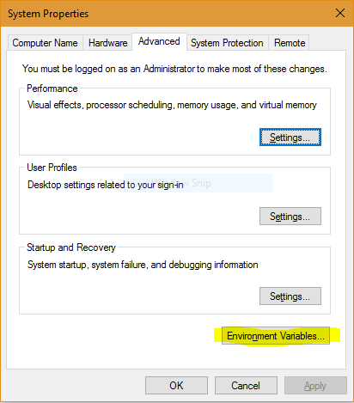
- Go to Control Panel -> System and Security -> System. Under Advanced System Setting option click on Environment Variables as highlighted below.

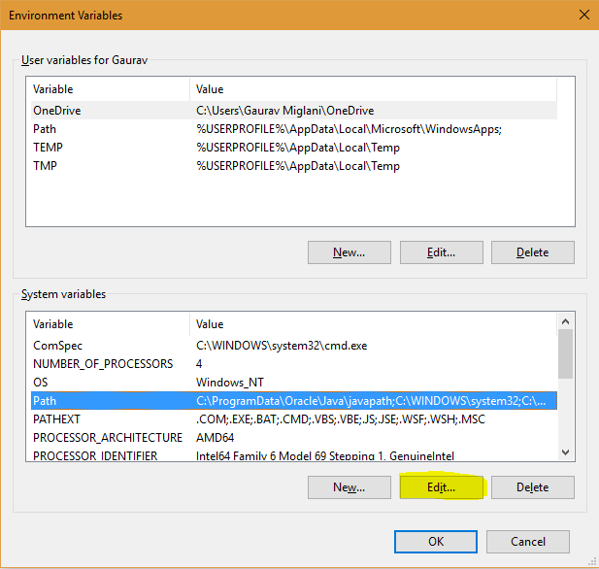
- Now, you have to alter the “Path” variable under System variables so that it also contains the path to the Java environment. Select the “Path” variable and click on Edit button as highlighted below.

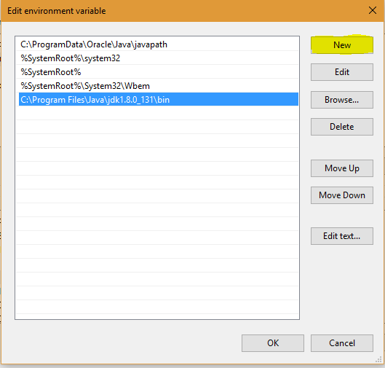
- You will see list of different paths, click on New button and then add path where java is installed. By default, java is installed in “C:\Program Files\Java\jdk\bin” folder OR “C:\Program Files(x86)\Java\jdk\bin”. In case, you have installed java at any other location, then add that path.

- Click on OK, Save the settings and you are done !! Now to check whether installation is done correctly, open command prompt and type javac -version. You will see that java is running on your machine.
- In order to make sure whether compiler is setup, type javac in command prompt. You will see a list related to javac.

JAVA Program Structure
import packagename1.*; import packagename2.*;

class classname
{
public static void main(String [] objname)
{
Variables declaration;
Executable statements;
}
}

Save => classname.java
Compile => javac programname.java Run => java classname

Example : Write a java program to display
“Welcome To JAVA”.
class Simple
{
public static void main(String [] t)
{
System.out.print(“Welcome To JAVA”);
}
}
Save => Simple.java
Compile => javac Simple.java Run => java Simple

What happens at compile time?
- At compile time, java file is compiled by Java Compiler (It does not interact with OS) and converts the java code into byte code.

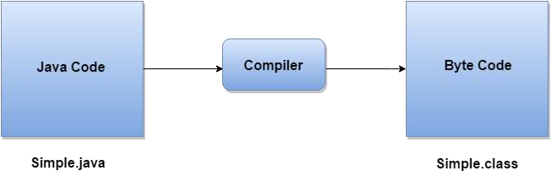

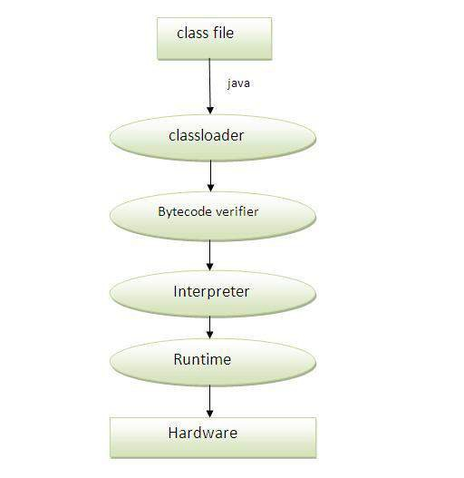
What happens at run time?
- The following steps are performed at run time:

Java Naming Conventions
- Java uses CamelCase as a practice for writing names of classes, methods, variables, packages, and constants.
- Camel case in Java Programming: It consists of compound words or phrases such that each word begins with a capital letter or first word with a lowercase letter, rest all words begins with capital.
- Classes and Interfaces :
  - Class names should be nouns, in mixed case with the first letter of each internal word capitalized. Interfaces name should also be capitalized just like class names.
  - Use whole words and must avoid acronyms and
abbreviations.
Examples:
System, DataInputStream, String, IOException etc.

- Methods :
  - Methods should be verbs, in mixed case with the first letter lowercase and with the first letter of each internal word capitalised.
Examples:
void getData( ); void readLine( );
void speedUp(int increment); void applyBrakes(int decrement);

- Variables : Variable names should be short yet meaningful.
  - Should not start with underscore(‘_’) or dollar sign ‘$’
characters.
  - Should be mnemonic i.e, designed to indicate to the casual observer the intent of its use.
  - One-character variable names should be avoided except for temporary variables.
  - Common names for temporary variables are i, j, k, m, and n for integers; c, d, and e for characters.
Examples:
int speed = 0; int age = 18; char c;

- Constants :
  - Should be all uppercase with words separated by underscores
(“_”).
Examples:
final int MIN_WIDTH = 4;
final int ROI=5;
- Packages :
  - A unique package name is always written in all-lowercase ASCII letters.
Examples:
java.io java.awt

Data Types in JAVA

- Data types are used to specify what type of value will be stored in a variable.
- In Java, data types define the type of data a variable can store. Java is a statically-typed language, which means all variables must be declared with a data type.
- Java has two main categories of data types:
- 🧩 1. Primitive Data Types
- These are predefined by the language and named by keywords. There are 8 primitive types in Java:
- Data Type | - Size (bits) | - Default Value | - Range | - Example
- Byte | - 8 | - 0 | - -128 to 127 | - byte b = 10;
- short | - 16 | - 0 | - -32,768 to 32,767 | - short s = 500;
- int | - 32 | - 0 | - -2^31 to 2^31-1 | - int i = 1000;
- long | - 64 | - 0L | - -2^63 to 2^63-1 | - long l = 10000L;
- float | - 32 | - 0.0f | - 1.4e-45 to 3.4e+38 | - float f = 3.14f;
- double | - 64 | - 0.0d | - 4.9e-324 to 1.8e+308 | - double d = 99.99;
- char | - 16 (Unicode) | - \u0000 | - 0 to 65,535 | - char c = 'A';
- boolean | - 1 (logical) | - false | - true or false | - boolean b = true;
- 📝 Update in 2025:

- Java still retains the same primitive types as before, but compiler support and API utilities have improved.
- Java 21+ added better integration for primitive types with records, pattern matching, and value classes (Project Valhalla - preview).
- 🧩 2. Non-Primitive (Reference/Object) Data Types

- These are created by the programmer and refer to objects. Theseinclude:
- Type | - Example | - Description
- String | - "Hello" | - Represents a sequence of characters
- Arrays | - int[] arr = {1,2}; | - Collection of elements of same type
- Classes | - Student s = new Student(); | - Custom object types
- Interfaces | - Runnable r = () -> {} | - Behavior templates
- Enums | - enum Day { MON, TUE } | - Fixed set of constants
- Records (Java 14+) | - record Point(int x, int y) | - Immutable data carriers (compact syntax)

Update in 2025:

- Java now heavily uses records and sealed classes to define custom types.
- Arrow, Polars, and Java interop frameworks support value-based object layouts (thanks to Project Valhalla).
- Non-primitive types benefit from pattern matching in switches and instanceof.

- 🔍 Difference Table (Primitive vs Non-Primitive)

- Feature | - Primitive | - Non-Primitive
- Defined by | - Java Language | - Programmer or libraries
- Stored in | - Stack | - Heap
- Default values | - Yes (0, false, etc.) | - null
- Null allowed? | - ❌ No | - ✅ Yes
- Mutable? | - N/A | - ✅ Usually
- Inheritance allowed | - ❌ No | - ✅ Yes
- 🚀 What's New in Java (2021–2025) for Data Types?
- Feature/Project | - Description & Use
- 🧬 Project Valhalla | - Introduces value class = lightweight, inline types
- 🧾 Records | - Concise, immutable data types for modeling data
- 🧠 Pattern Matching | - Cleaner control over types in instanceof and switch
- 🧱 Sealed Classes | - Restrict which classes can extend a type

- 📌 Summary
- Java's core primitive types haven't changed.
- Non-primitive types have evolved significantly: records, value classes, and pattern matching are game-changers.
- As of 2025, Java balances performance (Valhalla) and concise modeling (records + pattern matching).

Primitive Data Types in Java

Data Type | Size | Range
boolean | 1 Byte | true/false
Char | 2 Bytes | ‘\u0000’ to ‘\uffff’ (0 to 65535)
Byte | 1 Byte | -128 to 127
short | 2 Bytes | -32768 to 32767
Int | 4 Bytes | -2147483648 to 2147483647
Long | 8 Bytes | -2⁶³ to 2⁶³ - 1
Float | 4 Bytes | 3.4e-38 to 3.4e+38
Double | 8 Bytes | 1.7e-308 to 1.7e+308

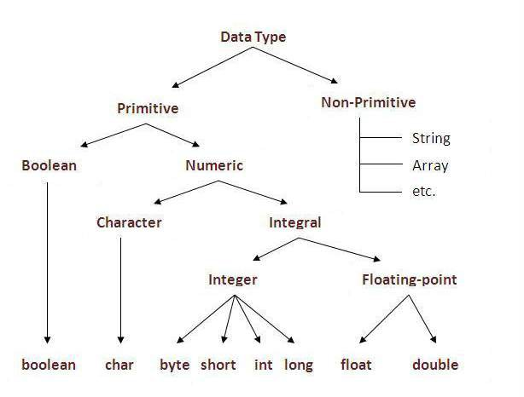

Type Casting
- This is the process of converting one type of value into another type.
- There are following two types of type casting supported by java:
  - Implicit Type Casting
  - Explicit Type Casting

Implicit Type Casting
- This is the process of converting one type of value into another type implicitly (automatically).
- Since java is a type safe language, therefore, it supports implicit type casting only for lower to higher data type conversion.
Example :
int i;
short s=4500;
i=s; // implicit type casting s=i; //Error

Explicit Type Casting
- This is the process of converting one type of value into another type forcefully.
Syntax :

Example :
(Data Type) Expression ;

int i=5000; short s;
s= (short) i; //Explicit Type Casting

Brainstorming on Type Casting
Question 1 : What will be the output of following program?
class Sample
{
public static void main(String[] S) { float age=4.5; System.out.println(age);
}
}

Options :
A. 4.5 B. 4.5000000 C. compile error D. runtime error

Question 2 : What will be the output of following program?
class Sample {
public static void main(String[] S) { int a=5, b=2;
int c;
c=a/b; System.out.println(c);
}
}

Options :
A. 2.5 B. 2 C. runtime error D. compile error

Comments in JAVA
- Non executable statements of a program are known as comments.
- Comments are used to explain Java code, and to make it more readable.
- There are 2 types of comments in java.
  - Single Line Comment
  - Multi Line Comment

Single Line Comment
- The single line comment is used to comment only one line.
Syntax:
// This is single line comment
Multi Line Comment
- The multi line comment is used to comment multiple lines of code.
Syntax:
/*
This is
multi line comment
*/

Command Line Arguments
- The arguments which are passed from the command line when we run the program, are known as command line arguments.
- These arguments can be accessed using the array name which has been passed to the main() as follows :
First Argument : array_name[0] Second Argument : array_name[1] and so on…

Getting Interactive Input in JAVA

1. Using Scanner class

- Scanner Class
  - Scanner is a built-in class available in java.util package. Java.util.Scanner class is a simple text scanner which can parse primitive types and strings.

Scanner t=new Scanner(System.in);

Commonly Used Methods of Scanner Class

Method | Description
public String next() | To get a string from the user
public String nextLine() | To get a string having multiple words from the user
public short nextShort() | To get a short value from the user
public int nextInt() | To get an integer value from the user
public long nextLong() | To get along value from the user
public int nextFloat() | To get a float value from the user
public int nextDouble() | To get a double value from the user

Example : Write a java program to get two nos. from the user. Display their sum.

import java.util.*; class Sum
{
public static void main(String [] S)
{
int a,b,c;
Scanner t=new Scanner(System.in); System.out.print(“Enter two nos. : ”); a=t.nextInt();
b=t.nextInt(); c=a+b;
System.out.print(“\n Sum is : “ + c);
}
}

Operators in JAVA
- Operators are the symbols which are used to operate operands.
- Java supports following operators :
  - Unary Operators (++ , -- )
  - Binary Operators
    - Arithmetic Operators(+, -, *, /, %)
    - Relational Operators (==, >, <, <=, >=, !=)
    - Logical Operators (&&, ||, !)
    - Assignment Operators ( =, +=, -=, *=, /=, %=)
  - Ternary Operator ( ? : )
  - Bitwise Operators ( <<, >>, &, |, ^, ~)

Control Statements in JAVA
- Control statements are the statements which are used to control the flow of a program.
- Java supports following three types of control statements
:
  - Conditional Statements
  - Repetition Statements
  - Jump Statements

- Conditional Statements : The statements
which are used to execute the statements on the basis of a condition are known as conditional statements.
Java supports following conditional statements :
- if statement
- If … else statement
- If … else if statement
- switch … case statement

  - Repetition/Looping Statements : The statements which are used to execute the statements repeatedly till some specific given condition is satisfied, are known as repetition statements.
Java supports following repetition statements :
- while loop
- for loop
- do … while loop
- for each loop/Enhanced for loop
4. for each loop/enhanced for loop : The Java for-each loop or enhanced for loop is introduced since J2SE 5.0. This loop is used to process all the elements of an array or a collection.
Syntax :
for (data_type variable_name : array_name/collection_name)
{
statement or block to execute
}

Example 1:
class Sample
{
public static void main(String s[])
{
int n[]={10,20,30,40,50};
for(int i : n)
{
System.out.println(i);
}
}
}

Example 2:
class Sample
{
public static void main(String s[])
{
String [] names = {“Amit“, “Sumit", “Mohit",
“Aman”, “Pankaj"};
for( String n : names )
{
System.out.println( n );
}
}
}

- Jump Statements : Jump statements are the
statements which are used to jump from a statement to another statement.
Java supports following jump statements :
- break
- Continue
- break statement : This jump statement is used to terminate a loop or exit from the switch case.
Syntax :
break;

Example: Java Break Statement with Loop
public class BreakExample
{
public static void main(String[] s)
{
for(int i=1;i<=100;i++)
{
if(i==5)
{
break;
}
System.out.print(i);
}
}
}
Output:
1 2 3 4

Java Break Statement with Nested For Loop
Example:
public class BreakExample
{
public static void main(String[] s)
{
for(int i=1;i<=3;i++)
{
for(int j=1;j<=3;j++)
{
if(i==2 && j==2)
{
break;
}
System.out.println(i+" "+j);
}
}
} }

Java Break Statement with Labelled For Loop
We can use break statement with a label. This feature is introduced since JDK 1.5. So,
we can break any loop in Java now whether it is outer loop or inner.
Example:
public class BreakExample
{
public static void main(String[] s)
{
aa:
for(int i=1;i<=3;i++)
{
bb:
for(int j=1;j<=3;j++)
{
if(i==2 && j==2)
{
break aa;
}
System.out.println(i+" "+j);
}
}
} }

Brainstorming on Looping Statements
Question 1 : How many times will “DVSGI” be printed in the below program?
class Sample_Loop1 {
public static void main(String[ ] s)
{
int i=1024;
for( ; i>0 ; i>>=1)
{
System.out.println("DVSGI");
} } }
Options :
A. 10 B. 11 C. compile error D. infinite

Question 2 : How many times will “DVSGI” be printed in the below program?
class Sample_Loop2 {
public static void main(String[ ] s) { int i=0;
do
{
if(i++ < 3)
{
Options :
- 1
- 2
- 3
- Infinite
System.out.println("DVSGI"); continue;
}
} while(false);
} }

Question 3 : What will be the output of following program? class Sample_Loop3 {
public static void main(String[ ] s) { int i=0;
switch(i)
{
case '0' : System.out.println("BCA"); break;
case '1' : System.out.println("MCA"); break;
Options :
- BCA
- MCA
- DVSGI
- Compile error
default : System.out.println("DVSGI");
}
}
}

Question 4 : What will be the output of following program? class Sample_Loop4
{
public static void main(String[ ] s)
{
boolean t=false; if(t) ;
else System.out.println("DVSGI");
}
Options :
- If block is executed.
- else block is executed.
- Error: misplaced else
- None
}

Question 5 : What will be the output of following program? class Sample_Loop5
{
public static void main(String[ ] s)
{
int t;
for(t=9; t!=0; t--)
System.out.print(t--);
}
}
Options :
- 9 7 5 3 1
- 9 8 7 6 5 4 3 2 1
- Infinite loop
- Error

Question 6 : What will be the output of the following program? class Sample_Loop6
{
public static void main(String[ ] s)
{
int m=5, n=10; do
{
n/=m;
} while(m-- > 0); System.out.println(n);
Options :
- 0
- 1
- Compile time error
- Run time error
}
}

Exercise
- Write a Program to input a number and check whether it is an even no
or odd no.
- Write a Program to input two numbers. Display larger one.
- Write a Program to input three numbers. Display smallest no.
- Write a Program to input salary. Calculate tax as follows :
Upto 5000, tax is 0
For next 10000, tax is 10%
For next 15000, tax is 20% And above tax is 30%
- Write a Program to display even nos. b/w 1 and 100.
- Write a Program to input a number. Display factorial of the no.
- Write a Program to input a number. Check either it is a perfect no. or not.
- Write a Program to input a number. Check either it is an armstrong no. or not.
- Write a Program to input a number. Check either it is a palindrome no.
or not.
- Write a Program to input a number. Check either it is a prime no. or not.

Exercise
- Write a Program to input a number and check whether it is a Pronic
Number.
Hint : A pronic number, oblong number, rectangular number or heteromecic number, is a number which is the product of two consecutive integers, that is, n (n + 1).
Example : 56 = 7 * 8 i.e. 56 is a product of two consecutive integers 7 and 8.
- Write a Program in Java to input a number and check whether it is
a Harshad Number or Niven Number or not.
Hint : A Harshad number (or Niven number), is a number that is divisible by the sum of its digits.
- Write a Program to input a number and check whether it is a Disarium Number.
Hint : A number will be called DISARIUM if sum of its digits powered with their respective position is equal to the original number.
For example 89 is a DISARIUM
(Workings 8¹+9² = 89, some other DISARIUM are 135, 175 etc)
- Write a Program in Java to input a number and check whether it is an Automorphic Number or not.
Hint : An automorphic number is a number which is present in the last digit(s) of its square.
Example: 25 is an automorphic number as its square is 625 and 25 is present as the last digits

Object Oriented Programming
- Object-Oriented Programming is a methodology to develop a program using classes and objects. It simplifies the software development and maintenance by providing following concepts:
  - Class
  - Object
  - Encapsulation
  - Data Hiding
  - Polymorphism
  - Inheritance
  - Message Passing

Class in JAVA
- In laymen term, a class is a category which can consist of its own features & behavior. In technical term, a class is used to define your own data type (non-primitive) which consists of its own features & behavior.
- In general, a class consists of following two types of members :
- Data Members (variables which are used to store the data).
- Methods (functions which are used to manipulate the data).

Access Specifiers/Modifiers
- These are used to specify the accessibility of the members of a class.
Java supports following access specifiers :
- Private : The private members of a class can only be accessed inside the class. The keyword private is used for this access specifier.
- Default : If no access specifier is given, by default it is default. They can be accessed inside the class as well as outside the class but within the same package only.
- Protected : The protected members of a class are same as default members of a class except that they can also be accessed in derived class outside the package. The keyword protected is used for this access specifier.
- Public : They can be accessed anywhere that is inside the class as well as outside the class. The keyword public is used for this access specifier.

Non-Access Modifiers
- There are following non-access modifiers which can be combined with access specifiers :
  - Static : The keyword static is used for this non-access modifier. The
static members of a class have following two properties:
    - Static members of a class occupy the memory only once for the whole class, they do not occupy the memory separately for every object of a class.
    - Static members of a class are accessed directly by using class name, creation of an object is not required to access static members of a class.
  - Final : The final keyword performs different-different tasks while being used with different members of a class as follows :
    - Using final with the data members of a class : if a data member of a
class has been declared using final keyword, it will become a constant.
    - Using final with the method of a class : if a method has been defined using final keyword, the method can not be overridden in derived class.
    - Using final with a class : if a class has been defined with final
keyword, the class can not be used as a parent class.

Defining Class in JAVA
- The keyword “class” is used to define a class in java as follows :
class classname
{
Data members declaration; Methods definition
}

Object in JAVA
- An object is an instance of a class that is used to access the members of a class.
- A object of a class in java can be created in following two ways :
1. class_name
obj_name; // Declaration
obj_name = new class_name(); // Instantiation

2.
class_name obj_name=new class_name();
//Declaration & Instantiation

Accessing Members of a Class
- The members of a class can be accessed in following two ways :
- Static Memebrs : They can be accessed directly by using the class name as follows :
class_name.member_name

- Instance Members : They are accessed with the help of an object(instance) of a class as follows :
object_name.member_name

Example1 : Write a menu driven program to maintain the details of an item in a departmental store. The output of the program should be as follows :
  - Purchase
  - Modify
  - Bill
  - Exit
Enter Your Choice :

Example2 : Write a menu driven java program to maintain the details of an account in a bank. The output of the program should be as follows :
- Open An Account
- Deposit Amount
- Withdraw Amount
- Balance Enquiry
- Exit
Enter Your Choice :

Array Object in JAVA
- As we can work with any type of array, we can also create an array of a class which is known as array object of a class.
- To work with an array object of a class, we are required to perform following two steps :
Step 1 : Declaring an array object
class_name [] obj_name = new class_name[size];
Account[] t = new Account[50];
Step 2 : Instanciating Elements of an array object obj_name[index] = new class_name();
t[0] = new Account(); t[1] = new Account(); And so on .......

Passing Object as method arguments
- As any type of arguments can be passed to a method, an object of the same class can also be passed to a method. Such mechanism is known as passing object as method arguments.
- The concept of passing objects as method arguments can easily be understood with the help of following example :
Example : Write a program to maintain the details of three rectangles. For first & second rectangles get details from the user. The details of third rectangle should be sum of first & second rectangle.

Returning Object From a method
- As any type of value can be get returned from a method, an object of the same class can also be get returned from a method. Such mechanism is known as returning object from a method.
- The concept of returning objects from a method can easily be understood with the help of following example :
Example : Define a class Complex to maintain the details of a complex number. Define a method sum() to add two complex numbers.

Constructors
- A constructor is a method having the same name as class name which is executed automatically whenever an object of a class is instantiated.
- A constructor can not have any return type not even void because the implicit return type of a constructor is a class itself.
- A constructor is used to initialize the data members of a class.

Type of Constructors
- There are following types of constructors supported by java :
- Default Constructor
- Parameterized Constructor
- Overloaded Constructor
- Copy Constructor

- Default Constructor
- A constructor having no arguments is known as default constructor.
Syntax :
classname()
{
;
;
}

Example :
class Item
{
int itno,qty; String name; float price; Item()
{
itno=price=qty=0;
name=“”;
}
}
Note : Now, an object of above defined item class will be created as follows :
classname objname=new classname(); Item t = new Item();

- Parameterized Constructor
- A constructor having one or more arguments is known as parameterized constructor.
Syntax :
classname(argtype1 argname1,argtype2 argname2,…)
{
;
;
}

Example :
class Item
{
int itno,qty; String name; float price;
Item(int no, String nm, floar pr, int qt)
{
itno=no; name=nm; price=pr; qty=qt;
}
}
Note : Now, an object of above defined item class will be created as follows : classname objname=new classname(argname1, argname1, argname1, argname1,); Item t = new Item(101,”Lux”,35,5);

- Overloaded Constructor
- This is the process of defining more than one constructors in a class.
Syntax :
classname( )
{
;
;
}

classname(argtype1 argname1,argtype2 argname2)
{
;
;
}

Example :
class Item
{
int itno, qty; String name; float price; Item()
{
Itno=price=qty=0; name=nm;
}
Item(int no, String nm, floar pr, int qt)
{
itno=no; name=nm; price=pr; qty=qt;
}
}
Note : Now, an object of above defined item class can be created in following 2 ways :
Item t1= new Item();
Item t 2= new Item(101,”Lux”,35,5);

- Copy Constructor
- This constructor is defined to initialize the data members of an object by the data members of another object.
Syntax :
classname(classname objname )
{
;
;
}

Example :
class Item
{
int itno, qty; String name; float price; Item()
{
Itno=price=qty=0; name=nm;
}
Item(Item x)
{
itno=x.itno; name=x.name; price=x.price; qty=x.qty;
}
void Getdata()
{
;
}
}
Note : Now, an object of above defined item class can be created in following 2 ways :
Item t1= new Item(); t1.Getdata();
Item t 2= new Item(t1);

Destructor
- A destructor is a method which is executed automatically whenever an object of a class is destroyed(deleted).
- A destructor is defined to free up the resource which are no longer required. But java provides the concept of garbage collection, which automatically free up the resource which are no longer required, therefore, defining destructor is not required in java. Even though, if you want to define a destructor, you can define as follows :
protected void finalize()
{
//statements like closure of database connection
}

Inheritance
- Inheritance is the process of inheriting the features of one class into another class.
- The idea behind inheritance is that you can create new classes that are built upon existing classes. When you inherit from an existing class, you can reuse methods and fields of the parent class. Moreover, you can add new methods and fields in your current class also.
- Inheritance represents the IS-A relationship which is also known as a parent-child relationship.
- The class from which the features are being inherited is known as Parent class, Base class or Super class.
- The class into which the features are being inherited is known as Child class, Derived class or Sub class.

Type of Inheritance

There are following five types of inheritance :
- Single Inheritance
- Multilevel Inheritance
- Hierarchical Inheritance
- Multiple Inheritance
- Hybrid Inheritance

Single Inheritance

This is the process of inheriting a class from single base class.

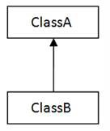

Multilevel Inheritance
- This is the process of inheriting a class from such base class which already inherits any other base class.
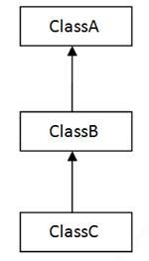

Hierarchical Inheritance
- This is the process of inheriting multiple classes from single base class.

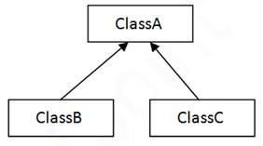

Multiple Inheritance

This is the process of inheriting a class from two or more base classes.

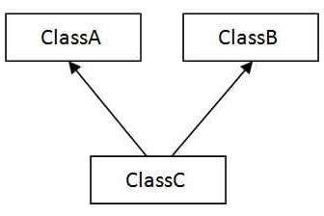

Hybrid Inheritance

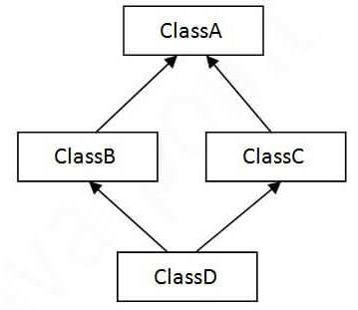
This is the combination of single and multiple inheritance both.

Note : Java supports only single inheritance and its family(multilevel & hierarchical).

Implementing Inheritance in Java
- The keyword “extends” is used to implement inheritance in java as follows :
class DerivedClassName extends BaseClassName
{
Define Additional Features

}

Example1 : Write a program to maintain the details of a Rectangle and a Cuboid.
Example2 : Define a class Student to maintain personal details (rollno, name) of a student. Define another class Marks to maintain personal details of a student & marks of two subjects. Define another class Total to maintain personal details of a student, marks of two subjects and total marks.
Write Main() to maintain all details of a student.

Making Inheritance More Efficient

Method Overriding
- This is the process of defining a method by the same name and signature in derived class which is already being inherited from the base class.

Constructor in Derived Class

- To define a constructor in derived class, we must be knowing following two mechanisms :
- Execution Sequence of Constructors
- Defining Constructor is optional or mandatory

Execution Sequence of Constructors
- Whenever an object of base class is instantiated, base class constructor is executed.
- Whenever an object of derived class is instantiated, both base class and derived class constructors are executed.

Defining Constructor is Optional/Mandatory
- It is optional to define a constructor in base class.
- Define constructor in derived class depends on base class constructor as follows :
  - In case of no base class constructor or base class default constructor, It is optional to define a constructor in derived class.
  - In case of base class parameterized constructor, It is mandatory to define a constructor in derived and it is also compulsory to call base class constructor from this derived class constructor as a first statement.

Abstract Class & Interface
- Data abstraction is the process of hiding certain details and showing only essential information to the user.
- Abstraction can be achieved with either abstract classes or interfaces.
- An abstract class is a class that is declared abstract—it may or may not have all abstract methods (an abstract method is a method that is declared without an implementation).
- Abstract classes can not be instantiated, they can only be subclassed.
- When an abstract class is subclassed, the subclass usually provides implementations for all of the abstract methods in its parent class. However, if it does not, then the subclass must also be declared abstract.

Defining Abstract Class in JAVA
- The keyword “abstract” is used to define an abstract class in java as follows :
abstract class classname
{
Data members declaration; Methods definition
Abstract methods declaration;
}

Example1 : Define an abstract class Shape to maintain the details of a shape. Now define following concrete classes :
- Rect – To main the details of a rectangle
- Square – To main the details of a square
- Triangle – To main the details of a triangle

Brainstorming on abstract class
- Can an abstract class contain constructors?
- Can we have an abstract class without any abstract method?
- An instance of an abstract class cannot be created, but can we have the reference of an abstract class?
- Can an abstract class also have final methods?

- An abstract class can contain constructors in Java. And a constructor of abstract class is
called when an instance of a inherited class is created.
Example :
abstract class Base
{
Base() { System.out.println("Base Constructor Called"); } abstract void fun();
}
class Derived extends Base
{
Derived() { System.out.println("Derived Constructor Called"); } void fun() { System.out.println("Derived fun() called"); }
}
class Main
{
public static void main(String args[])
{
Derived d = new Derived();
}
}
Output:
Base Constructor Called Derived Constructor Called

- We can have an abstract class without any abstract method. This allows us
to create classes that cannot be instantiated, but can only be inherited.
Example :
abstract class Base
{
void fun() { System.out.println("Base fun() called"); }
}
class Derived extends Base { } class Main
{
public static void main(String args[])
{
Derived d = new Derived();
d.fun();
}
}
Output:
Base fun() called

- An instance of an abstract class cannot be created, but we can have
references of abstract class.
Example :
abstract class Base
{
abstract void fun();
}
class Derived extends Base
{
void fun() { System.out.println("Derived fun() called"); }
}
class Main
{
public static void main(String args[])
{
Base b = new Derived(); b.fun();
}
}
Output:
Derived fun() called

- Abstract classes can also have final methods
Example :
abstract class Base
{
final void fun() { System.out.println(“Base fun() called"); }
}
class Derived extends Base {} class Main
{
public static void main(String args[]) {
Derived d = new Derived(); d.fun();
}
}
Output:
Base fun() called

Interfaces
- Interfaces are same as abstract classes that are used to define fully abstract data type. That means all the methods in an interface are declared with an empty body and are public and all fields(data members) are public, static and final by default.
- A class that implements interface must implement all the methods declared in the interface.
- A class can implement one or more interfaces. Therefore, we can say that interfaces provides the concept of multiple inheritance in java.

Type of Interfaces

There are following two types of interfaces supported by java :

Built-in Interfaces
  - User Defined Interfaces

- Built-in Interfaces

Predefined interfaces provided by java are known as built-in interfaces.
- To work with built-in interfaces, we are required to perform following steps :
- Step 1 : Implements all the required interfaces as follows :
class classname implements interfacename1,interfacename2,…
- Step 2 : Define all the methods of all the implemented interfaces

- User Defined Interfaces
- If you want to define your own interface, you can define, such interfaces are known as user defined interfaces.
- The keyword “interface” is used to define an interface as follows :
interface interface_name
{
Data members declaration & initialization; Methods declaration;
}

- Java program to demonstrate working of Interface
interface In1
{
final int x = 100; void Show();
}
// A class that implements the interface.
class SampleClass implements In1
{
public void Show()
{
System.out.println(“DVSGI");
}
public static void main (String[] s)
{
SampleClass M = new SampleClass(); M.Show();
System.out.println(M.x);
}
}
Output:
DVSGI 100

Packages

A package is a collection of similar type of classes and interface.
- Packages are used to prevent naming conflicts. For example there can be two classes with same name in two packages.

The main advantage of a package is that, by placing classes in a package, they can be used in any of the program just by importing the package.

Types of Packages

There are following two types of packages supported by java :

Built-in Packages
  - User Defined Packages

- Built-in Packages

Predefined packages provides by java are known as built-in packages.
- Mainly, java provides two built-in packages – java(core java) and javax(advance java). All other built-in packages are available inside these two main packages.

Most Commonly Used Built-in Packages
sql
applet
net
awt
util
io
lang
Java
- java.lang: Contains language support classes(e.g classed which defines primitive data types, math operations). This package is automatically imported.
- java.io: Contains classed for supporting input / output
operations.
- java.util: Contains utility classes which implement data structures like Linked List, Dictionary and support ; for Date / Time operations.
- java.applet: Contains classes for creating Applets.
- java.awt: Contain classes for implementing the components for graphical user interfaces (like button , ;menus etc).
- java.net: Contain classes for supporting networking operations.
- java.sql: Contain classes for database connectivity.

Working with built-in Packages

To work with built-in package, just we are required to import a package.
- A package can be imported in following two ways :
- Importing a whole package Syntax : import packagename.*; Example : import java.io.*;
- Importing a particular class
Syntax : import packagename.classname; Example : import java.io.DataInputStream;

- User Defined Packages

If you wan to define your own package, you can define, such packages are known as user defined packages.

Working with User Defined Packages

To work with user defined packages, we are required to perform following two steps :

Step 1 : Defining a package
- Step 2 : Importing a package

Step 1 : Defining a Package
- To define a package, we are required to perform following steps :
- Specify a package name as follows:
package package_name;
- Define a public class which is to be placed inside the package.
- Save your package program by the same name as class name with .java extension.
- Compile the package program by issuing following command :
javac -d . programname
- The above statement will compile the package program, if there is no error, the package will be created successfully.
- After successful creation of a package, the package program is not required, therefore either delete or rename the package program.

Step 2 : Importing a Package
- A user defined package will also be imported in the same manner in a built-in package is imported as follows :

import packagename.*;
OR

import packagename.classname;

Example1 : Define a package shape having following classes :
- Rect – To main the details of a rectangle
- Square – To main the details of a square
- Triangle – To main the details of a triangle

Example2 : Write a program to maintain the details of a square by importing above defined package.

Java Static Import
- Static import is a feature introduced in Java programming language version 5.

This feature facilitate the java programmer to access any static member(public) of a class directly. There is no need to qualify it by the class name.

Example of Static Import
import static java.lang.System.*;
class Example
{
public static void main(String s[])
{

out.println("Hello");
//Now no need of System.out

out.println("Java");
}
}

Exception Handling
- An exception is an abnormal condition that is caused by run time error in a program.
- Whenever an exception is generated in a program and the exception handler of such exception is found inside the program, the generated exception will be handled and the program will keep running successfully.
- But, if no such exception handler is found inside the program, every language has its own exception handler. Therefore, execution control will be transferred to that exception handler and the program will be terminated.

Exception Class Hierarchy

…
Exception
Throwable
NullPointerException
ArrayIndexOutOfBoundsException
ArithmeticException
SQLException
IOException

Types of Exceptions

There are following two types of exceptions :

Built-in Exceptions
  - User Defined Exceptions

- Built-in Exceptions
- Predefined exception provided by java which are generated implicitly are known as built-in exceptions.
- To work with built-in exceptions, just we are required to handle the exception.
- Java provides following four keywords to handle the exceptions :
  - try
  - catch
  - finally
  - throws

Exception Handling using try & catch
- try & catch blocks are used in combination.
- try block consists of the statements which may generate exceptions.
- Just follow the try block there must be a catch block consists of the statements to handle corresponding exception generated in try block.
- More than one catch blocks can also be given with one try block.

Syntax : try
{
Statements that may generate exceptions;
;
}
catch(Exception_class_name1 obj_name1)
{
Statements to handle exception;
;
}
catch(Exception_class_name2 obj_name2)
{
Statements to handle exception;
;
}
...

Exception Handling using try, catch & finally
- finally block can only be used in the combination of try block or try & catch block.
- Statements of finally block must be executed either exception is handled or not.
- finally block is a block that is used to execute important code such as closing connection, stream etc.

Syntax :
try
{
Statements that may generate exceptions;
;
}
catch(Exception_class_name1 obj_name1)
{
Statements to handle exception;
;
}
catch(Exception_class_name2 obj_name2)
{

}
finally
{

}
Statements to handle exception;
;

Statements must be executed;
;

Usage of finally block
- Let's see the different cases where java finally block can be used.
Case 1 : where exception doesn't occur class TestFinallyBlock{
public static void main(String s[]){
try{
int data=125/5; System.out.println(data);
}
catch(NullPointerException e)
{System.out.println(“Inside catch block”);}
finally
{System.out.println("finally block is always executed");} System.out.println("rest of the code...");
}
}
Output : 25
finally block is always executed rest of the code...

Case 2 : where exception occurs and not handled class TestFinallyBlock{
public static void main(String s[]){
try{
int data=125/0; System.out.println(data);
}
catch(NullPointerException e)
{System.out.println(“Inside catch block”);}
finally
{System.out.println("finally block is always executed");}
System.out.println("rest of the code...");
}
}
Output : finally block is always executed Exception in thread main
java.lang.ArithmeticException:divide by zero

Case 3 : where exception occurs and handled class TestFinallyBlock{
public static void main(String s[]){
try{
int data=125/0; System.out.println(data);
}
catch(ArithmeticException e)
{System.out.println(“Inside catch block”);}
finally
{System.out.println("finally block is always executed");}
System.out.println("rest of the code...");
}
}
Output : Inside catch block
finally block is always executed
rest of the code…

Exception Handling using throws
- Whenever an exception is generated in a program, there are two ways to deal with the exception – either handle the exception using try/catch, try/catch/finally block or further throwing an exception.
- throws keyword is used to further throwing an exception.
- To further throw an exception, throws keyword must be given with the method name from which exception is to be further thrown.
- While further throwing an exception using throws keyword, the exception must be thrown up to command prompt.

Syntax :
public return_type methodName() throws ExpClsName1,…
{
Statements ;
;
;
}

- User Defined Exception
- Exceptions may be useful also. Therefore, If you want to define your own exception, you can define. Such exception are known as user defined exceptions.
- To work with user defined exceptions, we are required to perform following three steps : Step 1 : Defining an Exception
Step 2 : Generating(throwing) an Exception Step 3 : Handling an Exception

Step 1 : Defining an Exception
- To define your own exception, you are just required to define a class by inheriting Exception class or any of its child class.
- It is customary to give both a default constructor and a constructor that contains a detailed message.
- Therefore, An exception can be defined as follows : class ExpCLS_Name extends Exception
{
ExpCLS_Name() { } ExpCLS_Name(String msg)
{ super(msg); }
}

Step 2 : Generating(throwing) an Exception

- The keyword throw is used to generate an exception as follows :
throw Exception_OBJ_Name;

Step 3 : Handling an Exception
- A user defined exception will also be handled in the same manner in built-in exceptions are handled that is by using try & catch block, try, catch & finally block or by using throws keyword.

Multithreading
- To learn Multithreading, firstly we must be knowing Multitasking.
Multitasking : Multitasking is the process of performing more than one tasks at the same time. Multitasking can be achieved in following two ways :
- Process Based Multitasking
- Thread Based Multitasking

- Process Based Multitasking : Whenever two or more processes are being executed at the same time, such mechanism is known as Process Based Multitasking.
- Thread Based Multitasking : Whenever two or more parts(tasks) of the same process are being executed at the same time, every task is known as the thread & if there are more than one threads, such mechanism is known as Multithreading.

Thread States
  - In the life cycle of the thread, a thread
may be in following several states :

Born


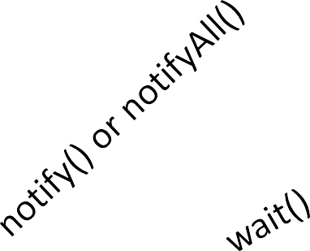
start()
Sleep Interval Expires
I/O Completion
Ready
yield()
Assigns the
processor
Running
sleep()
Waiting
Sleeping
Dead
Blocked

Implementing Multithreading in Java

  - Java provides following two mechanisms to implement multithreading :
- By Implementing Runnable Interface
- By Extending Thread Class

Implementing Multithreading using Runnable Interface

  - Runnable is a built-in interface available in java.lang package.
  - This interface provides the mechanism to implement multithreading in java.
  - Runnable interface provides a method public void run() that is executed automatically whenever a thread is started.

Steps to Implement Multithreading using
Runnable Interface
Step 1 : Define a class by implementing Runnable interface as follows :
class Class_Name implements Runnable
Step 2 : Now, declare as many objects of Thread class as much multithreading you want to achieve as follows :
Thread ObjName1,ObjName2,…
Step 3 : Now, instantiate all of the above created Thread objects as follows :
Objname1=new Thread(this);
or
Objname1=new Thread(Runnable target);

Step 4 : Now, start the execution of all of the above created Threads by calling start() of Thread class as follows :
ObjName1.start(); ObjName2.start();
………
Step 5 : Now, define run() of Runnable interface as per your requirement as follows :
public void run()
{
……….
}

Example1 : Write a program by using the concept of multithreading to produce following outptut :
2
1
4
3
6
5
8
7
10
9

Thread Class
- Thread is a built-in class available in java.lang package.
- This class provides the mechanism to implement multithreading in java.
- This class provides a method public void run() that is executed automatically whenever a thread is started.
- A Thread class object can be created in following ways :
Thread objname=new Thread();
Thread objname=new Thread(“name”);
Thread objname=new Thread(Runnable Target);
Thread objname=new Thread(Runnable Target,”name”);

Methods of Thread Class
- start() : This method is used to start the execution of a thread.
Syntax : Thread_objname.start();
- sleep() : This method is used to suspend the execution of a thread up to given number of milliseconds. This method generates an Exception.
Syntax : Thread_objname.sleep(milliseconds);
- isAlive() : This method returns true if thread is alive otherwise returns false.
Syntax : boolean varname=Thread_objname.isAlive();
- setName() : This method is used to specify the name of a thread.
Syntax : Thread_objname.setName(“name”);

- getName() : This method is used to retrieve the name of a thread.
Syntax : String objname=Thread_objname.getName();
- currentThread() : This is a static method of Thread class that returns the reference of currently running thread.
Syntax : Thread objname=Thread.currentThread();
- setPriority() : Higher priority threads are executed earlier than lower priority threads irrespective of their starting sequence. The priority of a thread can be set between 1 (Thread.MIN_PRIORITY) and 10 (THREAD.MAX_PRIORITY). If no priority has been given to a thread, by default it is 5 (Thread.NORM_PRIORITY). This method is used to specify the priority of a thread.
Syntax : Thread_objname.setPriority(priority);

- getPriority() : This method is used to retrieve the priority of a thread.
Syntax : int varname=Thread_objname.getPriority();
- suspend() : This method is used to suspend the execution of a thread until it has not been resumed explicitly.
Syntax : Thread_objname.suspend();
- resume() : This method is used to resume the execution of a thread
that has been suspended using suspend().
Syntax : Thread_objname.resume();
- yield() : This method is used to pause a thread temporary and allow other threads to be executed.
Syntax : Thread_objname.yield();

- join() : Some times sub threads are alive and main thread is dead. In such case program will not work properly. Therefore, main thread must not be dead if any sub thread is alive. To do so, sub threads must be joined with main thread. This method is used to join sub thread with main thread.
Syntax : SubThread_objname.join();

Steps to Implement Multithreading using
Thread class
Step 1 : Define a class by inheriting Thread class as follows :
class Class_Name extends Thread
Step 2 : Override the method public void run() as per your requirement in the above defined class as follows :
public void run()
{
;
;
}

Step 3 : Now, define another class having main() and create as many objects of above defined class as much multithreading you want to implement.
Step 4 : Now, start the execution of all the threads created in step 3 by calling start().

Example1 : Write a program by using the concept of multithreading to produce following outptut :
2
1
4
3
6
5
8
7
10
9

class MyThread extends Thread
{
MyThread(String name)
{
setName(name);
}
public void run()
{
String nm=getName();
if(nm.equals("even"))
{
for(int i=2;i<=10;i+=2)
{
System.out.print("\n" + i); try
{
sleep(10);
}

catch(Exception e) { }
}
}
else if(nm.equals("odd"))
{
for(int j=1;j<=9;j+=2)
{
System.out.print("\n" + j); try
{
sleep(10);
}
catch(Exception e) { }
}
}
}
}

class MyThreadDemo
{
public static void main(String[] s)
{
MyThread t1=new MyThread("even"); MyThread t2=new MyThread("odd"); t1.start();
t2.start();
}
}

Synchronization
- Multi-threaded programs may often come to a situation where multiple threads try to access the same resources and finally produce erroneous and unforeseen results.
- So it needs to be made sure by some synchronization method that only one thread can access the resource at a given point of time.
- Java provides a way of creating threads and synchronizing their task by using synchronized blocks. Synchronized blocks in Java are marked with the synchronized keyword. A synchronized block in Java is synchronized on some object. All synchronized blocks synchronized on the same object can only have one thread executing inside them at a time. All other threads attempting to enter the synchronized block are blocked until the thread inside the synchronized block exits the block.

- This synchronization is implemented in Java with a concept called monitors. Only one thread can own a monitor at a given time. When a thread acquires a lock, it is said to have entered the monitor. All other threads attempting to enter the locked monitor will be suspended until the first thread exits the monitor.
- A synchronized block can be created as follows :
synchronized
{
;
;
}
- A complete method can be synchronized as follows :
synchronized access_specifier return type methodname()
{
;
;
}

Inter Thread Communication
- Inter-thread communication or Co-operation is all about allowing synchronized threads to communicate with each other.
- Cooperation (Inter-thread communication) is a mechanism in which a thread is paused running in its critical section and another thread is allowed to enter (or lock) in the same critical section to be executed. It is implemented by following methods of Object class:
  - wait()
  - notify()
  - notifyAll()
- wait() method : This method causes current thread to release the lock and wait until either another thread invokes the notify() method or the notifyAll() method for this object, or a specified amount of time has elapsed.

- notify() method : This method wakes up a single thread that is waiting on this object's monitor. If any threads are waiting on this object, one of them is chosen to be awakened. The choice is arbitrary and occurs at the discretion of the implementation.
- notifyAll() method : This method wakes up all threads that are waiting on this object's monitor.

Example of inter thread communication in java
class Customer{
int amount=10000;

synchronized void withdraw(int amount){ System.out.println("going to withdraw..."); if(this.amount<amount){
System.out.println("Less balance; waiting for deposit...");
try{wait();}catch(Exception e){}
}
this.amount-=amount; System.out.println("withdraw completed...");
}
synchronized void deposit(int amount){ System.out.println("going to deposit..."); this.amount+=amount; System.out.println("deposit completed... "); notify(); } }
class Test{
public static void main(String args[]){ final Customer c=new Customer(); new Thread(){
public void run(){c.withdraw(15000);}
}.start();
new Thread(){
public void run(){c.deposit(10000);}
}.start();

}}

class Test
{
public static void main(String args[])
{
final Customer c=new Customer();
new Thread(){
public void run(){c.withdraw(15000);}
}.start();

new Thread(){
public void run(){c.deposit(10000);}
}.start();
Output: going to withdraw...
Less balance; waiting for deposit... going to deposit...
deposit completed... withdraw completed

}
}

AWT
- AWT stands for abstract window toolkit. This is a built-in package available in java package.
- This package provides all the tools (classes & interfaces) that are required to develop any windows applications in java.
- Therefore, this package must be imported in every windows application program in java.

Class Hierarchy of AWT Package
…
List
TextField
Button
Label
Component
Container
Frame
Window
Dialog

Panel

Frame
- Frame is a container class that provides a window. Whenever we are developing any window based application, first of all we are required to create a window.
- A window can be created by creating an object of Frame class as follows :
Syntax: 1. Frame obj_name=new Frame();
2. Frame obj_name=new Frame(“title”);

Methods of Frame Class
- setTitle() : This method is used to specify the title of a frame.
Syntax : Frame_objname.setTitle(“title”);
- getTitle() : This method is used to retrieve the title of a frame.
Syntax : String objname=Frame_objname.getTitle();
- setSize() : This method is used to specify the size(width, height) of a frame.
Syntax : Frame_objname.setSize(width,height);
- show() : This method is used to show a window.
Syntax : Frame_objname.show();

- hide() : This method is used to hide a frame.
Syntax : Frame_objname.hide();
- setVisible() : This method is used to show/hide a frame.
Syntax : Frame_objname.setVisible(true/false);
- dispose() : This method is used to release all the resources used by this frame , its sub components and all of its own childen.
Syntax : Frame_objname.dispose();
- setBackground() : This method is used to specify the bavkground color of a frame.
Syntax:
- Frame_objname.setBackground(Color.COLORNAME);
- Frame_objname.setBackground(Color objname);

- setLocationRelativeTo(Component c) : This method is used to specify the location of the window relative to the specified component. If the component is not currently showing, or c is null, the window is centered on the screen.
Syntax :
Frame_objname. setLocationRelativeTo(Component c) ;

Example1 : Develop a windows application having the title MyWindow.

Components
  - Components are the controls that are placed on a container to design user interface.
  - Java.awt package provides a separate class for every component by inheriting Component class such as Label, TextField, Button, List, Checkbox etc.

Label
  - This class provides the component label that is used to display text.
Syntax :
- Label obj_name=new Label();
- Label obj_name=new Label(“text”);

Methods of Label Class
- setText() : This method is used to specify the text of a label.
Syntax : Label_objname.setText(“text”);
- getText() : This method is used to retrieve the text of a label.
Syntax : String objname=Label_objname.getText();
- setAlignment() : This method is used to specify the alignment of the text with respect to label
Syntax : Label_objname.setAlignment(alignment);
- getAlignment() : This method is used to retrieve the alignment of a label.
Syntax : int varname=Label_objname.getAlignment();

Adding Components to a Container
  - Components can be added to a container in following two ways :
    - According to Layout
    - According to User’s Specifications

- Adding Components according to Layout
  - According to layout, components can be added to a container in following four ways, because there are four types of layouts as follows:
    - BorderLayout
    - FlowLayout
    - CardLayout
    - GridLayout

- Adding Components according to BorderLayout
  - According to border layout, components are added on the border of a container.
  - According to border layout, at most five components can be added to a container because there are only five positions(East, West, North, South & Center) in border layout.
  - Center is the default position in border layout.

Steps for Adding Components According to BorderLayout
Step 1 : Create an object of BorderLayout class as follows :
BorderLayout Objname = new
BorderLayout ();
Step 2 : Set the layout of a container to BorderLayout as follows :
ContaineName.setLayout(BorderLayoutO
bjname);

Step 3 : Now, components can be added to a container by calling add() of container class as follows :
ContainerObjname.add(CombonentN ame, position);
Example :
f.add(l1,BorderLayout.EAST); f.add(l2,BorderLayout.North);

- Adding Components according to FlowLayout
  - According to flow layout, components are added in a flow that can be left, right or center and any number of components can added to a container.

Steps for Adding Components According to FlowLayout
Step 1 : Create an object of FlowLayout class as follows :
FlowLayout Objname = new
FlowLayout (flow);
Step 2 : Set the layout of a container to FlowLayout as follows :
ContaineName.setLayout(FlowLayoutO
bjname);

Step 3 : Now, components can be added to a container by calling add() of container class as follows :
ContainerObjname.add(CombonentN ame);
Example :
f.add(l1);
f.add(l2);

- Adding Components according to CardLayout
  - According to card layout, components are added as cards are placed that is one on another and therefore only one component will be visible.

Steps for Adding Components According to CardLayout
Step 1 : Create an object of CardLayout class as follows :
CardLayout Objname = new
CardLayout ();
Step 2 : Set the layout of a container to CardLayout as follows :
ContaineName.setLayout(CardLayoutO
bjname);

Step 3 : Now, components can be added to a container by calling add() of container class as follows :
ContainerObjname.add(CombonentN ame);
Example :
f.add(l1);
f.add(l2);

- Adding Components according to GridLayout
  - According to grid layout, components are added in a grid (in the form of rows and columns that is tabular format.).

Steps for Adding Components According to GridLayout
Step 1 : Create an object of GridLayout class as follows :
GridLayout Objname = new
GridLayout (rows,cols);
Step 2 : Set the layout of a container to GridLayout as follows :
ContaineName.setLayout(GridLayoutO
bjname);

Step 3 : Now, components can be added to a container by calling add() of container class as follows :
ContainerObjname.add(CombonentN ame);
Example :
f.add(l1);
f.add(l2);

- Adding Components according to User’s
Specification

  - While developing windows applications, most of the time we are required to add components according to user’s specification.

Steps for Adding Components
According to User’s Specification
Step 1 : Every container has a layout by default. Therefore, set the layout of a container to null as follows :
ContaineName.setLayout(null);
Step 2 : Now, specify the position & size of every component by calling setBounds() of Component class as follows :
ComponentName.setBounds(left,top,width,height);

Step 3 : Now, components can be added to a container by calling add() of container class as follows :
ContainerObjname.add(CombonentN ame);
Example :
f.add(l1);
f.add(l2);

TextField
  - This class provides the component text box that is used to get data from the user.
Syntax :
- TextField obj_name=new TextField();
- TextField obj_name=new TextField(“text”);

Methods of TextField Class
- setText() : This method is used to specify the text of a text box.
Syntax : TextField_objname.setText(“text”);
- getText() : This method is used to retrieve the contents/text of a text box.
Syntax : String objname=TextField_objname.getText();
- setEditable() : This method is used to specify either the contents of a text box can be edited or not directly.
Syntax : TextField_objname.setEditable(true/false);
- isEditable() : This method returns true if text box is editable
otherwise returns false.
Syntax : boolean varname=TextField_objname.isEditable();

- setEchoChar() : This method is used to specify a character that is to be displayed instead of actual text.
Syntax : TextField_objname.setEchoChar(‘character’);
- getEchoChar() : This method returna a character that is to be displayed.
Syntax : char varname=TextField_objname.getEchoChar();

Button
  - This class provides the component command button that can be used to start an action, suspend an action or resume an action.
Syntax :
- Button obj_name=new Button();
- Button obj_name=new Button(“text”);

Methods of Button Class
- setLabel() : This method is used to specify the text/caption of a button.
Syntax : Button_objname.setLabel(“text”);
- getLabel() : This method is used to retrieve the caption/text of a button.
Syntax : String objname=Button_objname.getLabel();

Exercise1 : Develop a windows application to provide following output.
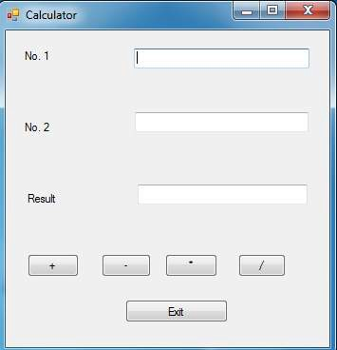

Exercise2 : Develop a windows application to provide following output.
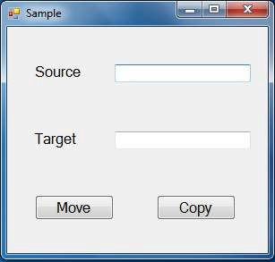

Exercise3 : Develop Logon dialog box.
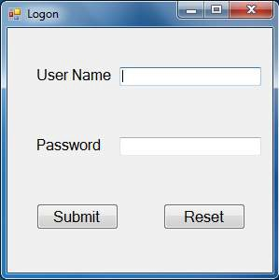

Event handling in Java (Event Delegation Model)
- While working with java corresponding to every event there is a class known as event class & corresponding to every event class there is a Listener.
- A Listener is an interface that is used to handle events.
- Corresponding to every event class there is a separate Listener available in java.awt.event package to handle that particular event.

Steps To Perform Event Handling

Step 1 : Import the package java.awt.event as follows :
import java.awt.event.*;
Step 2 : Implements all the required Listeners as as follows :
class ClassName implements ListenerName1,…

Step 3 : Now, bind all the components (for which event is to be handled) with the required listener as follows :
ComponentName1.addListenerName(this); ComponentName2.addListenerName(this);
………………………..
Step 4 : Now, Define all the methods of all the implemented Listeners.

Event Handling of a Button
- Whenever a user clicks on a button, action event is generated.
- Corresponding class to action event is ActionEvent class.
- Corresponding Listener to ActionEvent class is ActionListener.
- ActionListener consists of following method :
public void actionPerformed(ActionEvent objname)

List Class
- This class provides the component list box which provides a list of choices from which a user can select one or more choices.
Syntax :
- List obj_name=new List();
- List obj_name=new List(size);
- List obj_name=new List(size,true/false);

Methods of List Class
- add() : This method is used to add an item to a list box.
Syntax :
  - List_objname.add(“item”);
  - List_objname.add(“item”,index);
- remove() : This method is used to remove an item from a list box.
Syntax : List_objname.remove(“item”/index);
- removeAll() : This method is used to remove all items from a list box.
Syntax : List_objname.removeAll();
- getItemCount() : This method counts the items of a list box .
Syntax : int varname=List_objname.getItemCount();

- getSelectedItem() : This method returns the item selected by the user.
Syntax : String objname=List_objname.getSelectedItem();
- getSelectedItems() : This method will work in case of multi select list box only. This method returns all the items selected by the user.
Syntax : String[] objname=List_objname.getSelectedItems();
- getSelectedIndex() : This method returns the index of the item selected by the user.
Syntax : int Varname=List_objname.getSelectedItem();
- getSelectedIndexes() : This method returns the index of all the items selected by the user.
Syntax : int[] Varname=List_objname.getSelectedItem();

- getItem() : This method is used to retrieve a particular item from a list box.
Syntax : String objname=List_objname.getItem(index);
- Select() : This method is used to select an item in a list box.
Syntax : List_objname.Select(index);
- isIndexSelected () : This method returns true if a particular item in a list box is selected otherwise returns false.
Syntax : boolean Varname=List_objname.isIndexSelected(index);

Event Handling of a List Box
  - A list box may generate following two types of events :
- ActionEvent : This event is generated whenever a user double clicks on an item of a list box. This event will be handled same as previous.

- ItemEvent : This event is generated whenever a user single clicks on an item of a list box. This event will be handled same as previous. Corresponding class to this event is ItemEvent class and corresponding listener is ItemListener to handle this event.
The interface ItemListener consists of following method :
public void itemStateChanged(ItemEvent objname)

Exercise4 : Design following interface for a Book Shop :
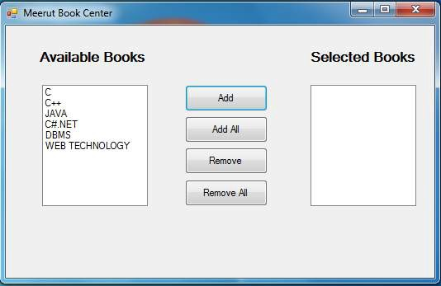

Exercise5 : Design following interface for a Book Shop :
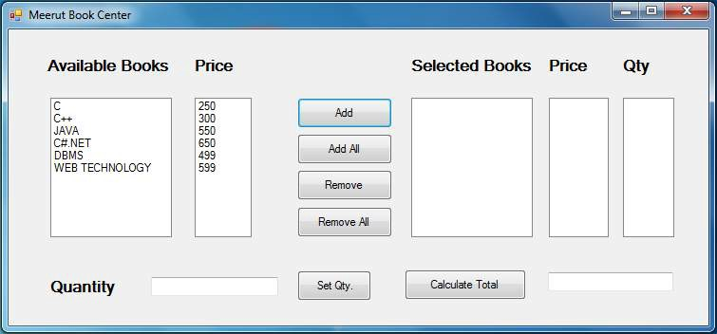

Choice Class
- This class provides the component combo box. A combo box is also known as drop down list box that provides a list of choices from which a user can select only one choice at a time.
Syntax :
- Choice obj_name=new Choice();

Methods of Choice Class
- Same as all methods of List class except multiselect family.
Events : Whenever a user clicks on an item of a combo box, item event is generated that will be handled same as previous.

Example 1 : Develop a windows application having following interface :

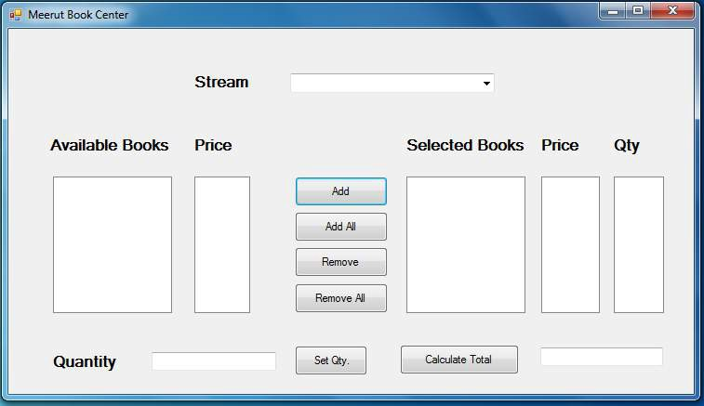

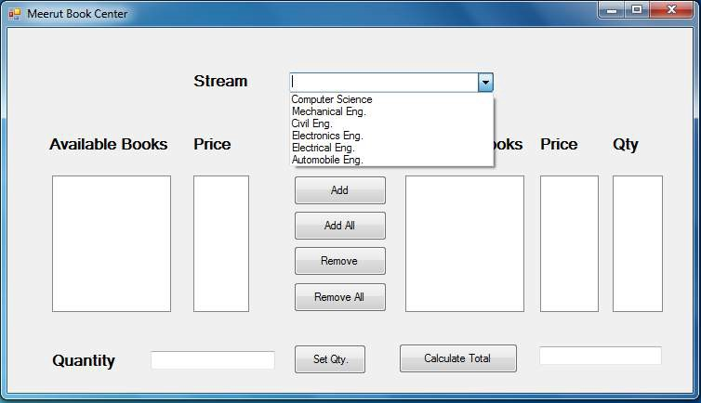

Checkbox Class
  - This class provides the component check box.
  - Checkboxes provides a list of choices from which a user can select as many choices as he/she wants.
Syntax:
- Checkbox obj_name=new Checkbox();
- Checkbox obj_name=new Checkbox(“text”);
- Checkbox obj_name=new Checkbox(“text”,true/false);

Methods of Checkbox Class
- setLabel() : This method is used to specify the text of a check box.
Syntax : Checkbox_objname.setLabel(“text”);
- getLabel() : This method is used to retrieve the text of a checkbox.
Syntax : String objname=Checkbox_objname.getLabel();
- getState() : This method returns true if a check box is checked by the user otherwise returns false.
Syntax : boolean varname=Checkbox_objname.getState();
- setState() : This method is used to check or uncheck a check box.
Syntax : Checkbox_objname.setState(true/false);

Events of Checkbox Class

  - Whenever a user clicks on a check box, item event is generated that will be handled same as previous.

Example 1 : Develop a windows application having following interface :

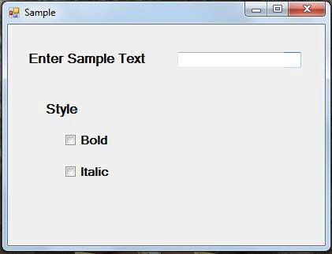

Radio Buttons
    - They are also known as Option Buttons.
    - Radio buttons provide a list of choices & from one group of radio buttons, a user can select only one choice at a time.
    - Therefore, to work with radio buttons, we are required to perform following two steps
:
Step 1 : Creating a Group : To create a group, CheckboxGroup class is used as follows :
Syntax: CheckboxGroup obj_name=new CheckboxGroup();

Step 2 : Creating Radio Buttons : After creating a group, radio buttons can be created by creating(placing) checkboxes in the above created group as follows :
Syntax:
- Checkbox obj_name=new Checkbox(“text”,GrpName);
- Checkbox obj_name=new Checkbox(“text”,true/false,GrpName);

Example 1 : Develop a windows application having following interface :
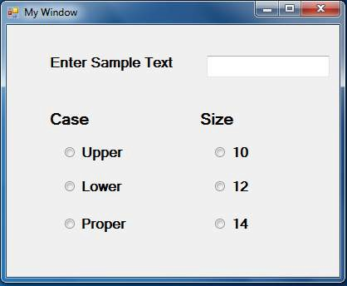

Scrollbar Class
- This class provides the component scroll bar(Horizontal/Vertical).
- A scroll bar is used to get numeric data from the user with in the given specific range.
Syntax:
  - Scrollbar obj_name=new Scrollbar();
  - Scrollbar obj_name=new Scrollbar(orientation);
  - Scrollbar obj_name=new Scrollbar(orientation, currentvalue, thumbsize, minvalue, maxvalue);

Methods of Scrollbar Class
- setOrientation() : This method is used to specify the orientation of a
scrollbar.
Syntax : Scrollbar_objname.setOrientation(Scrollbar.HORIZONTAL/Scrollbar.VERTICAL);
- getOrientation) : This method is used to retrieve the orientation of a
scrollbar.
Syntax : int varname=Scrollbar_objname.getOrientation();
- setMinimum() : This method is used to specify the minimum value of the scrollbar.
Syntax : Scrollbar_Objname.setMinimum(value);
- getMinimum() : This method returns the minimum value of the scrollbar.
Syntax : int varname=Scrollbar_Objname.getMinimum();

- setMaximum() : This method is used to specify the maximum value of the scrollbar.
Syntax : Scrollbar_Objname.setMaximum(value);
- getMaximum() : This method returns the maximum value of the scrollbar.
Syntax : int varname=Scrollbar_Objname.getMaximum();
- setUnitIncrement() : This method is used to specify by what value, the value of a scrollbar is to be increased/decreased whenever a user clicks on scroll buttons.
Syntax : Scrollbar_Objname.setUnitIncrement(value);
- getValue() : This method returns the current value of the scrollbar
Syntax : int Varname=Scrollbar_objname.getValue();

Events of Scrollbar Class

  - Whenever a user clicks on scroll buttons in a scrollbar, adjustment event is generated. Corresponding class to adjustment event is AdjustmentEvent class & corresponding listener is AdjustmentListener.
  - AdjustmentListener interface consists of following method :
public void adjustmentValueChanged(AdjutmentEvent Objname)

Example 1 : Design Color Dialog Box having following interface :
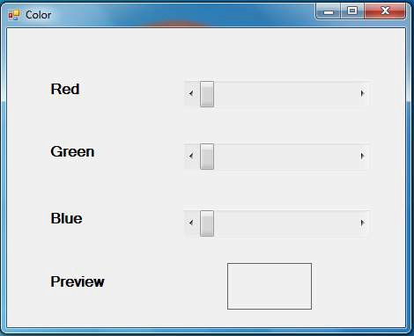

Example 2 : Design Temperature Converter having following interface :
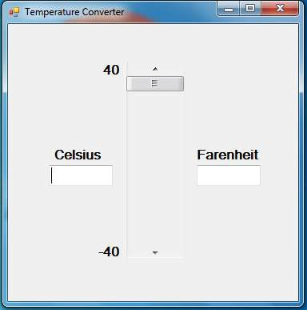

Working With Menus
- While developing windows application, it must be user friendly.
- A windows application can be made more user friendly by providing menus.
- Java provides following three classes to work with menus :
- MenuBar
- Menu
- MenuItem

1. MenuBar Class
- This class provides the component menu bar.
- A menu bar is a horizontal line just below the title bar.
- A menu bar consists of one or more menus.
Syntax:
MenuBar obj_name=new MenuBar();

Methods of Menubar Class
- add() : This method is used to add a menu to a menu bar.
Syntax : MenuBar_objname.add(Menu_Objname);

- Menu Class
- This class provides the component menu.
- A menu is a pad that is displayed on a menu bar.
- A menu consists of one or more menu items.
Syntax:
Menu obj_name=new Menu(“text/caption”);

Methods of Menu Class
- add() : This method is used to add a menu item to a menu.
Syntax : Menu_objname.add(MenuItem_Objname);
- addSeparator() : This method is used to add a separataaor line to a menu at the current position.
Syntax : Menu_objname.addSeparator();

2. MenuItem Class
- This class provides the component menu item.
- A menu item is a command that is used to perform a particular task.
Syntax:
- MenuItem obj_name=new MenuItem(“text/caption”);
- MenuItem obj_name=new MenuItem(“text”, MenuShortcut Objname);
Note : MenuShortcut ms = new MenuShortcut
(KeyEvent.VK_A, false);

Methods of MenuItem Class
1. setEnabled() : This method is used to enable/disable a menu item..
Syntax : MenuItem_objname.setEnabled(true/false);

Events of MenuItem Class
  - Whenever a user clicks on a menu item, Action Event is generated, that will be handled same as previous.

Note : After creating a MenuBar, Menus & MenuItems, the MenuBar is to be set on a Frame(container) as follows :
Frame_Objname.setMenuBar(MenuBar_Objname);

Example 1 : Design a windows application having following interface :
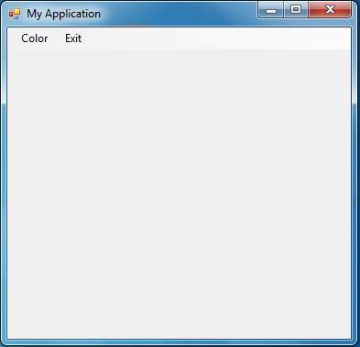

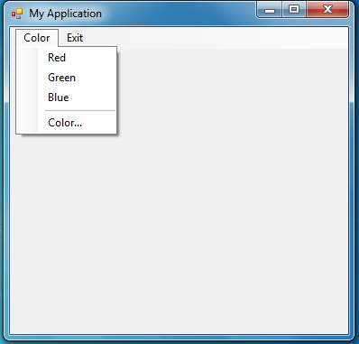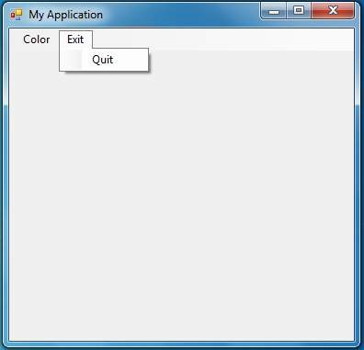

General Events
- Key Events
- Mouse Events
- Window Events

  - Key Events
- Key events are generated whenever we perform any operation with the key board such as pressing a key, releasing a key etc.
- Key Events are used to trap a key.
- Corresponding class to key events is KeyEvent class & corresponding listener is KeyListener.

Methods of KeyListener

- public void keyPressed(KeyEvent Objname)
- public void keyReleased(KeyEvent Objname)
- public void keyTyped(KeyEvent Objname)

  - Mouse Events
- Mouse events are generated whenever we perform any operation with the mouse such as pressing a mouse button, releasing a mouse button, clicking a mouse button etc.
- Corresponding class to mouse events is MouseEvent class & corresponding listener is MouseListener.

Methods of MouseListener

- public void mousePressed(MouseEvent Objname)
- public void mouseReleased(MouseEvent Objname)
- public void mouseClicked(MouseEvent Objname)
- public void mouseEntered(MouseEvent Objname)
- public void mouseExited(MouseEvent Objname)

  - Window Events
- Window events are generated whenever we perform any operation with the window such as opening a window, closing a window, minimizing a window etc.
- Corresponding class to window events is WindowEvent class & corresponding listener is WindowListener.

Methods of WindowListener

- public void windowOpened(WindowEvent Objname)
- public void windowActivated(WindowEvent Objname)
- public void windowDeactivated(WindowEvent Objname)
- public void windowIconified(WindowEvent Objname)
- public void windowDeiconified(WindowEvent Objname)
- public void windowClosing(WindowEvent Objname)
- public void windowClosed(WindowEvent Objname)

